Dump impact on BS4 field for

fast under vacuum magnets and

slow outside vacuum magnet.

B.Balhan / J.Borburgh

***Under Vacuum BS4:***

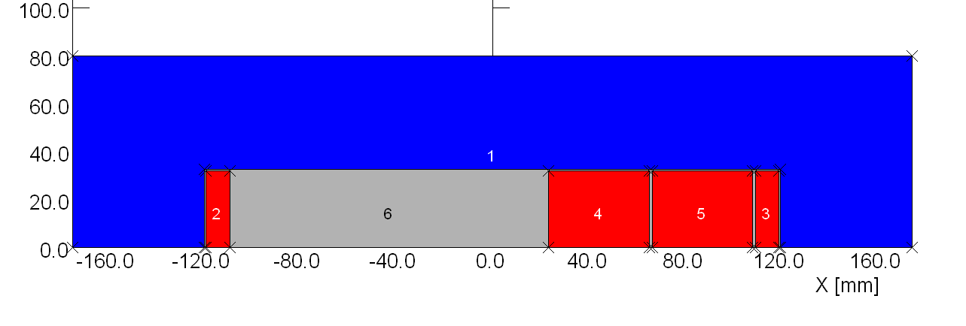

Gap 65 mm

34 Amps/ mm2 coil section ( 10/86 mm)

B0 @ Inom = 0.42 T

Ramp switch off 0.5 ms

2 Graphite Blocks conductivity 1.0E+05 Siemens/m,

starting at 23.5mm from 0.

32/85 mm air gap 1 mm.

Yoke material VM111

**Flux density distribution @ I nominal, t=0s**

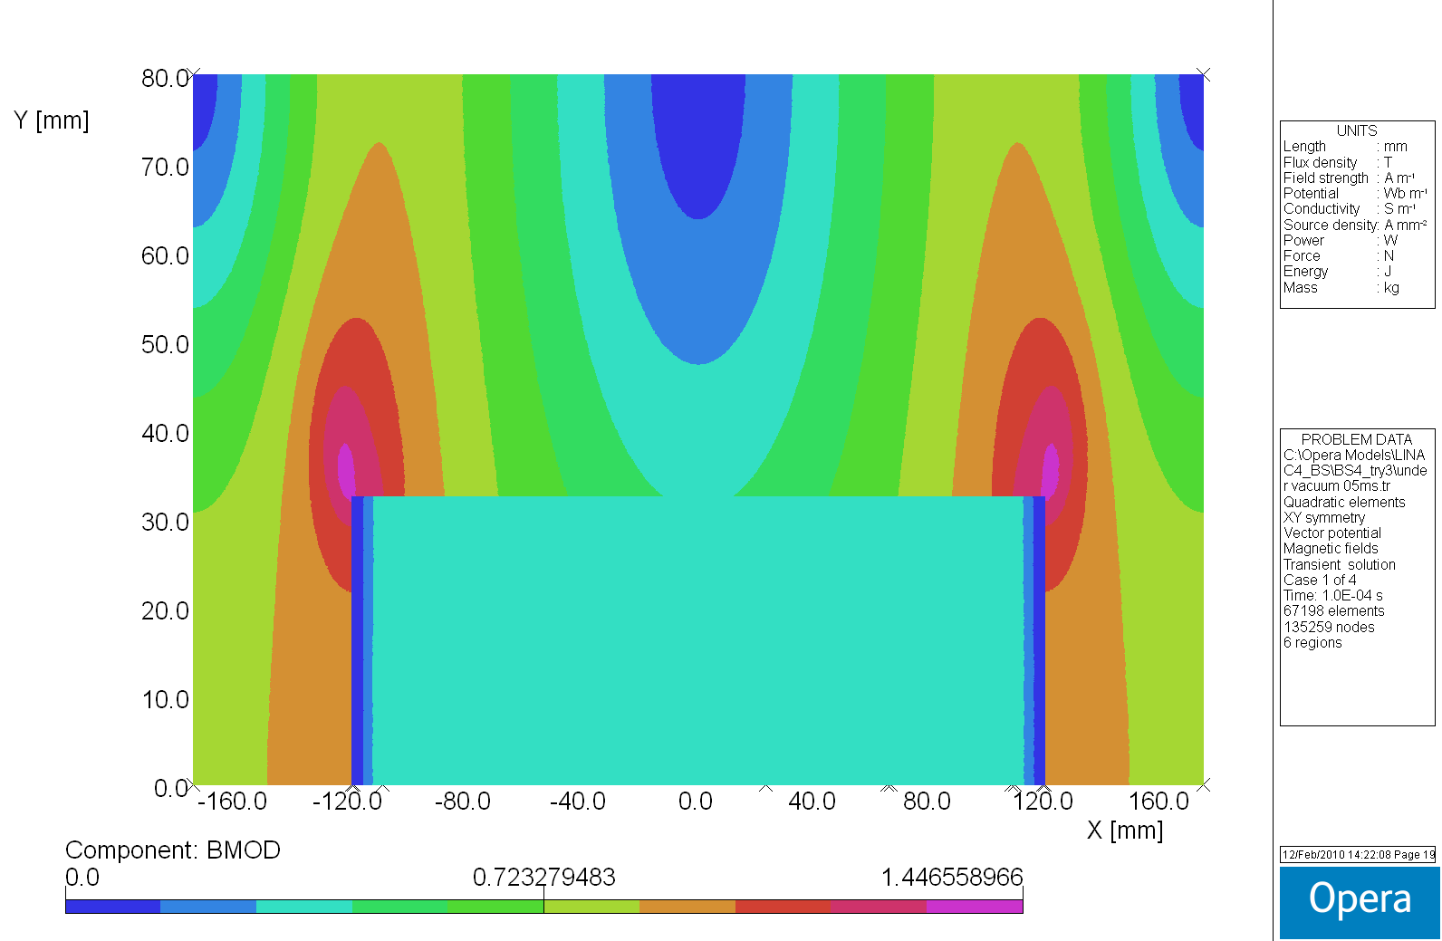

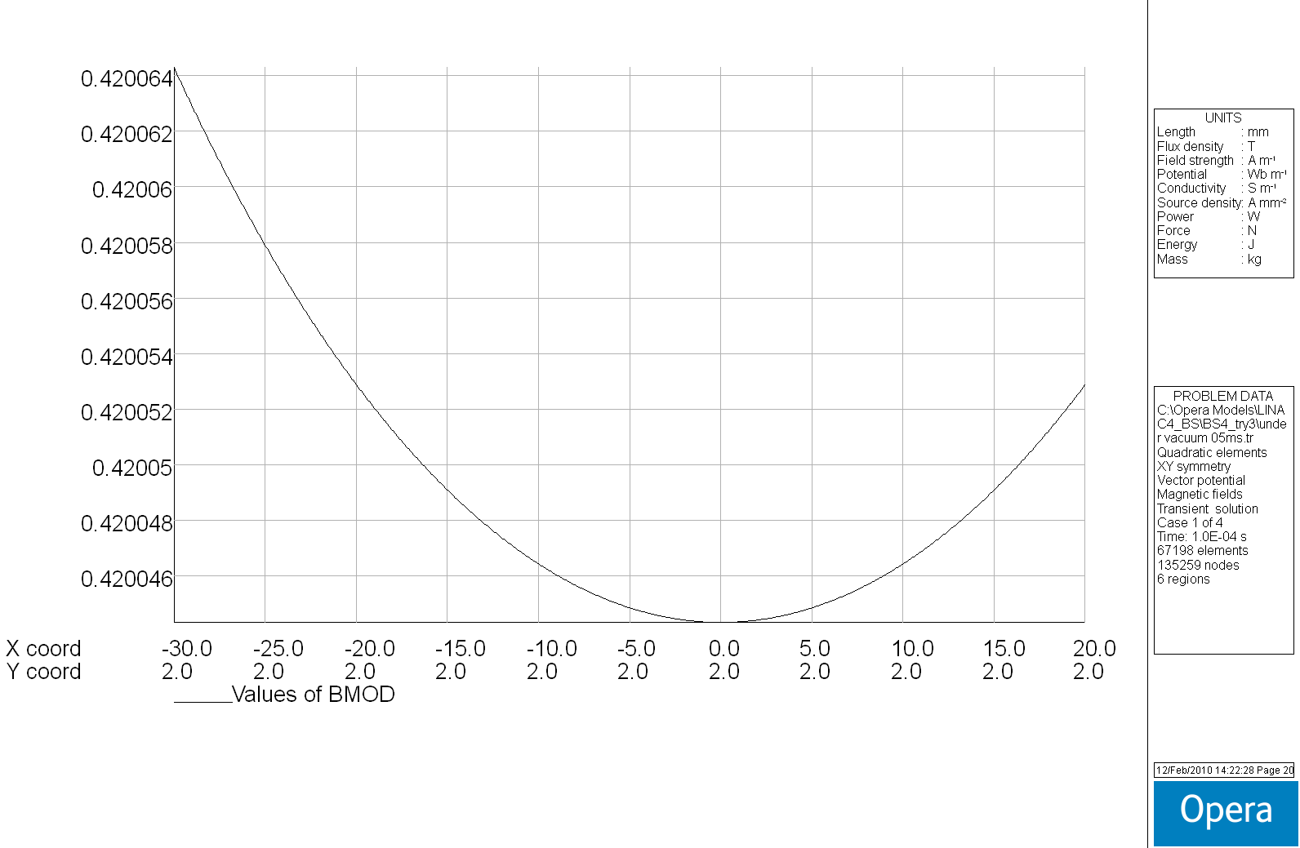

**Flux density distribution @ I=0amps, t=6.0E-04s**

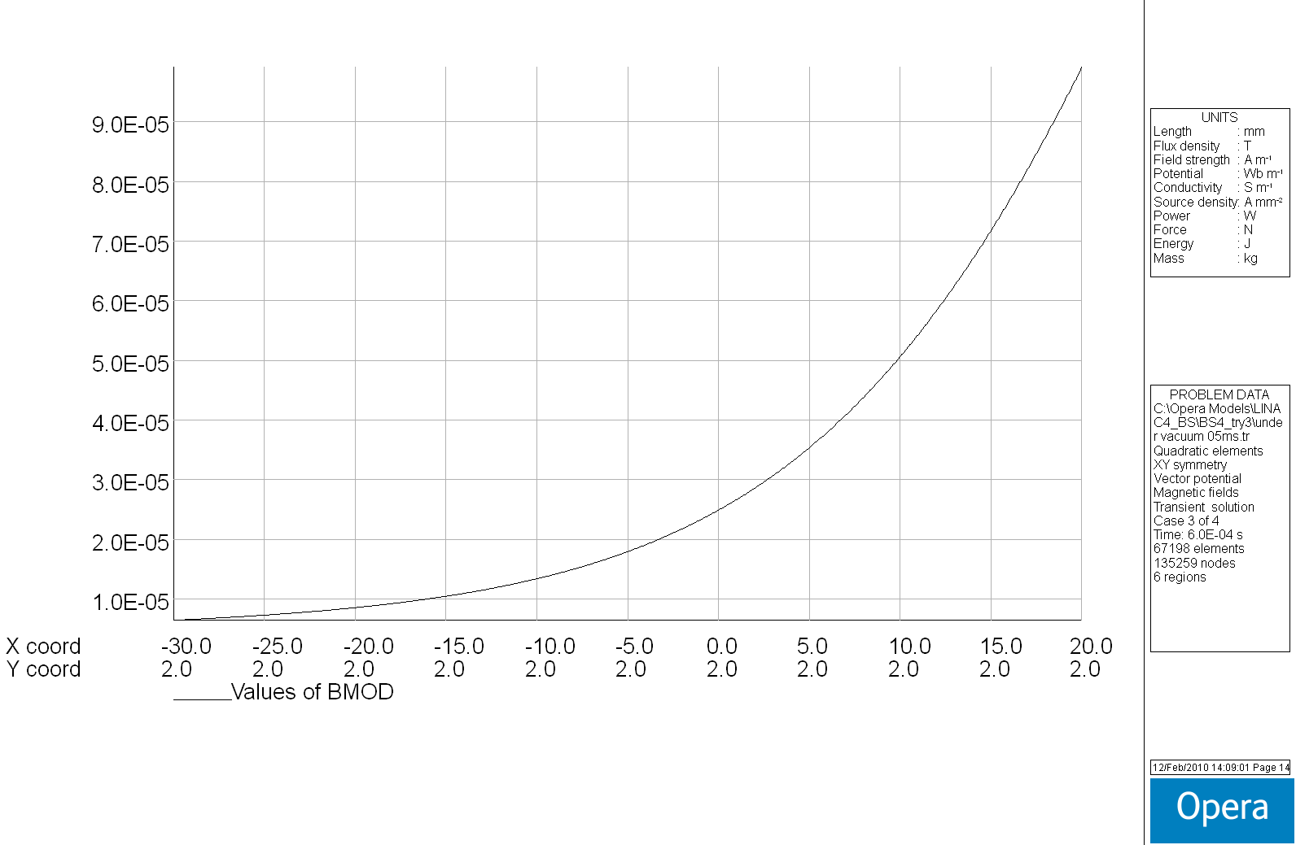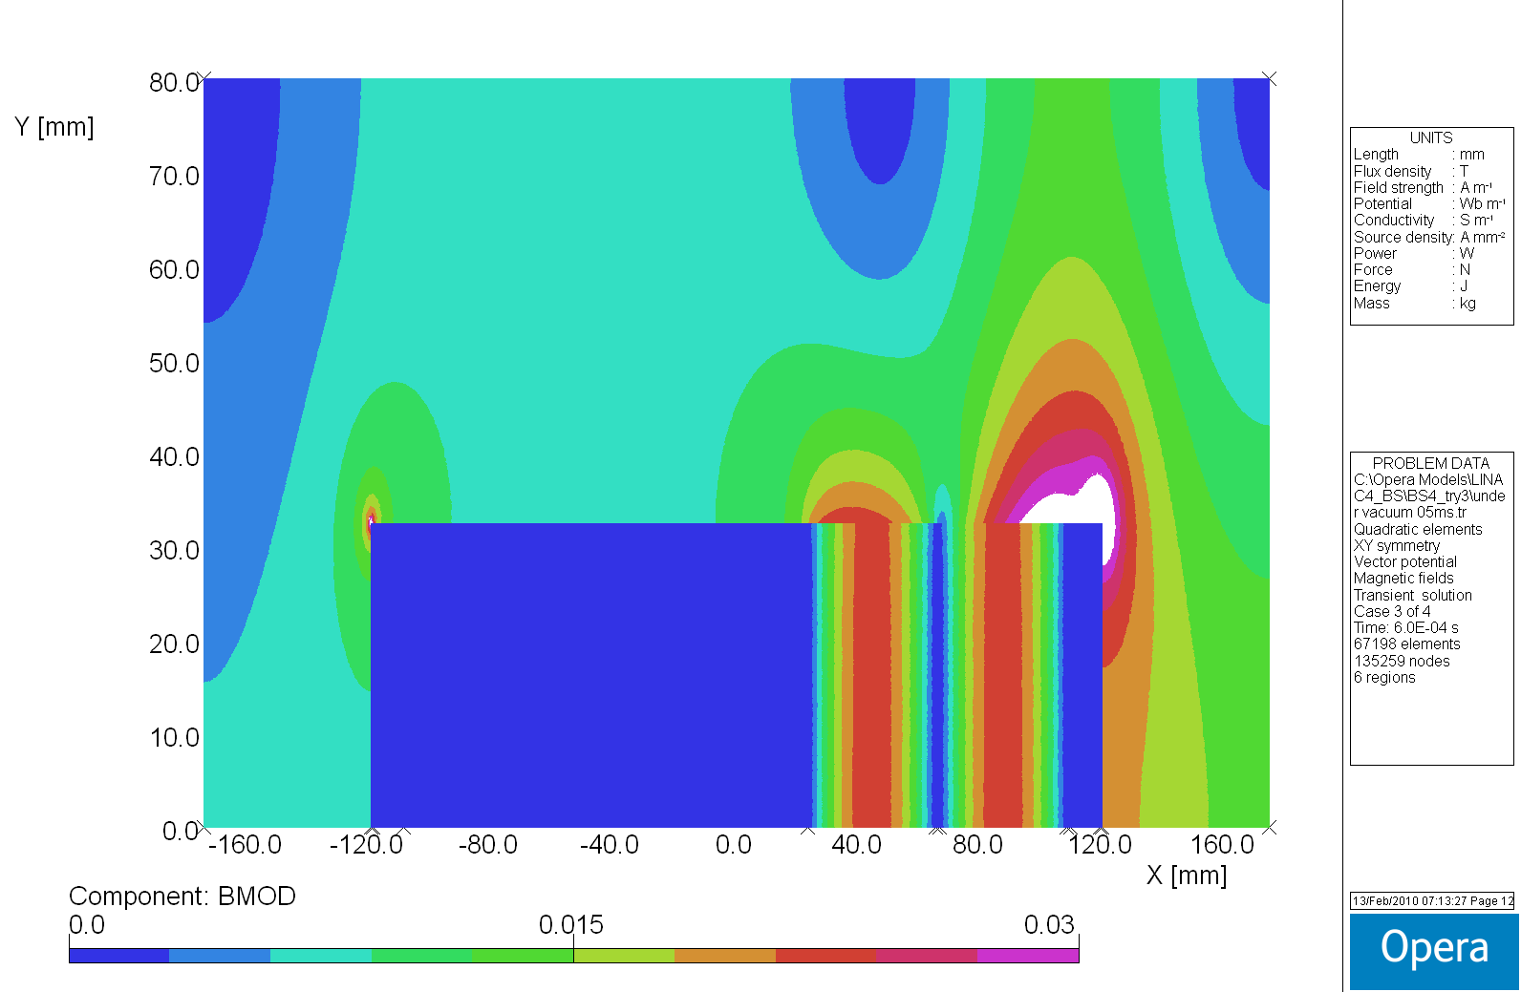

***Outside Vacuum BS4:***

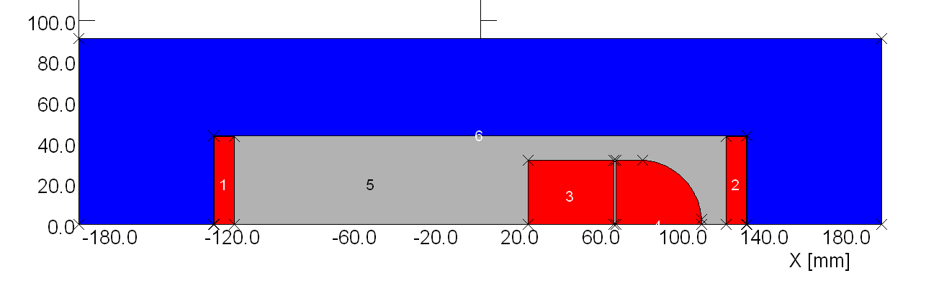Study based on ceramic chamber design…

dumpsection

Magnet Gap 87 mm, Gap inside ceramic tube 65 mm

34 Amps/ mm2 coil section ( 10/86 mm)

B0 @ Inom = 0.4217 T

Ramp switch off 5 ms

2 Graphite Blocks conductivity 1.0E+05 Siemens/m,

starting at 23.5mm from 0

31.5/85 mm air gap 1 mm R 19 mm.

Yoke material VM111

**Flux density distribution @ Inominal, t=0s**

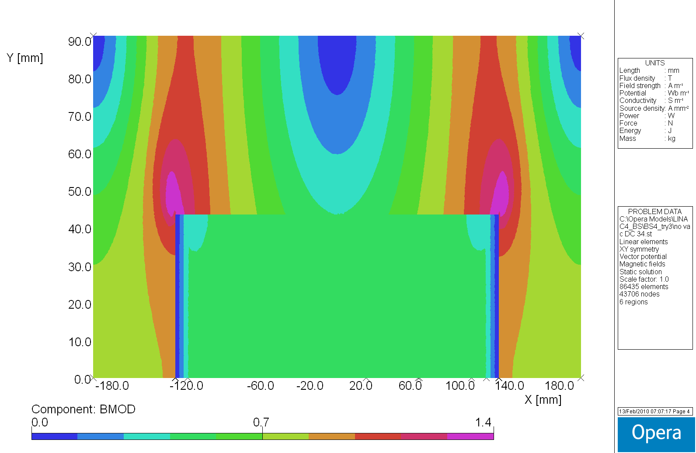

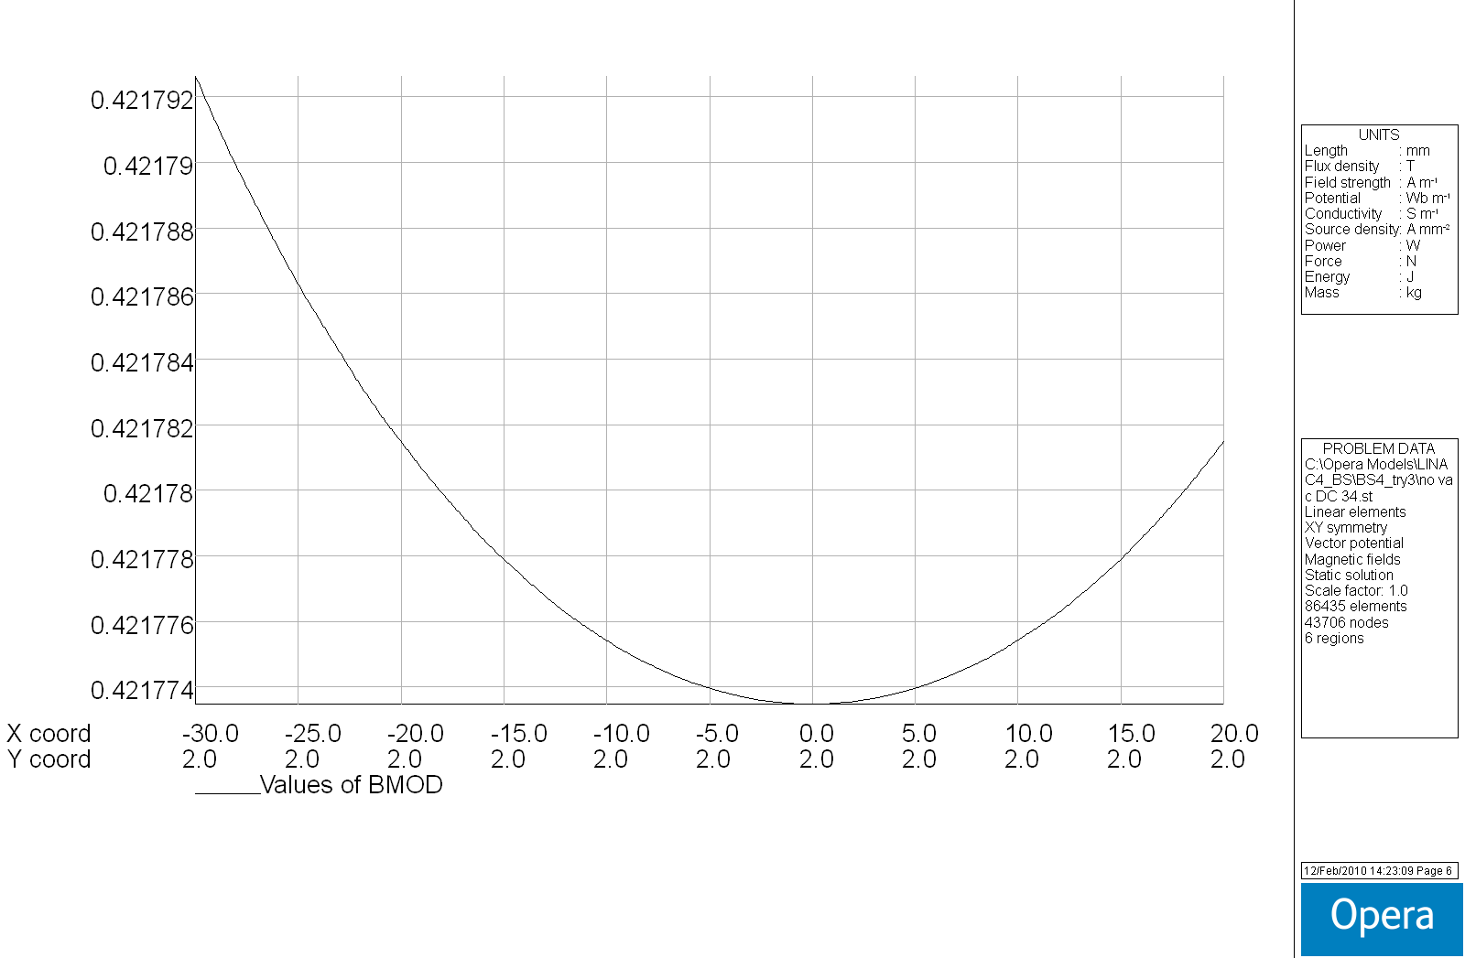

**Flux density distribution @ I=0amps, t=5.1E-03s**

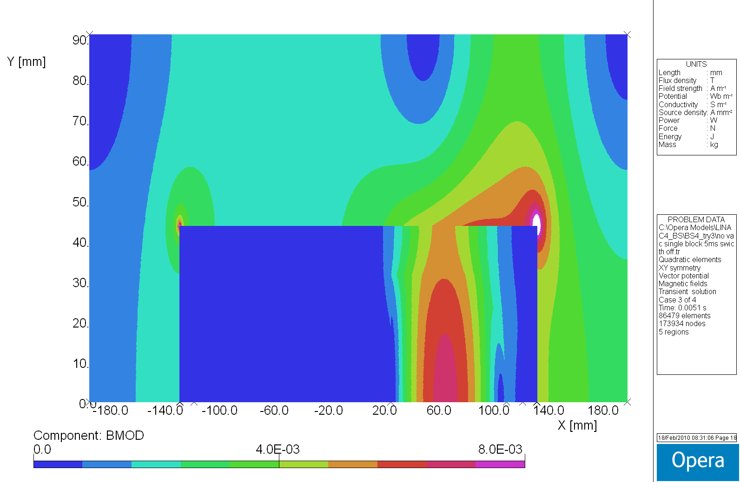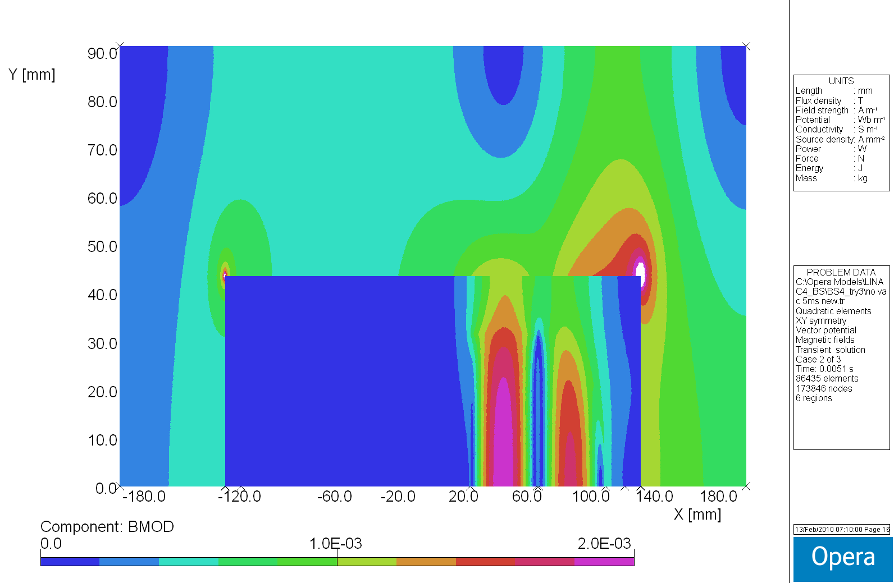**Sliced Blocks (2 parts) Single Massive Block**

