FLUX2D geometry used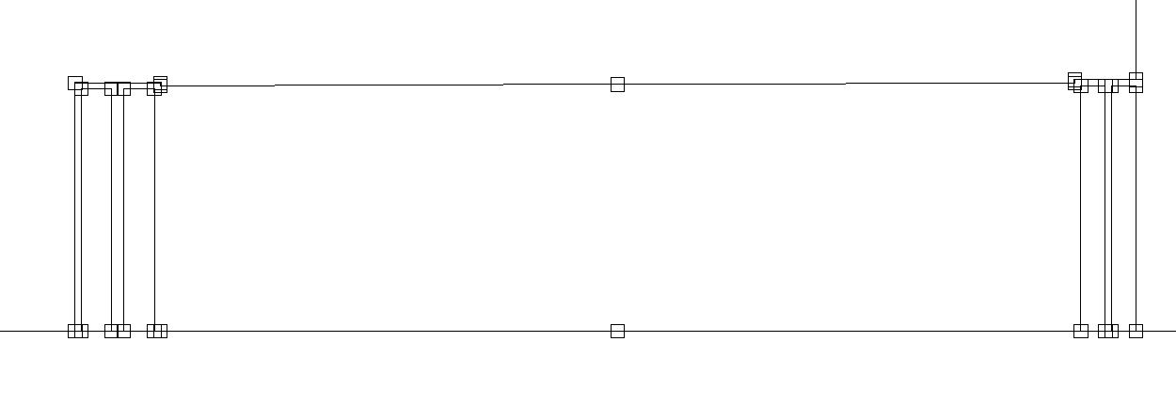half gap height at magnet center: 40.5 mm

Available gap width : +/- 75 mm (i.e. 150 mm total)

Pole face slope : 0.5 mm

Current per turn 10939 A

No cooling channels

BH curve used : VM111

# Field distrubution inside the magnet



**β0 @ midplane**

**338.863 E-3Tesla**

**Field distrubution inside the magnet β0 ± $\frac{1.32\%}{2}$**



|  |
| --- |
| MAX :341.0995 |
| MIN : 336.6265 |

# Magnetic field in the magnet gap on the midplane



X value (mm) Y value (Tesla)

0(-75mm) 340.48E-3 0 (-30 mm) 339.8164E-3

150 (+75mm) 337.00E-3 40 (0) 338.863

60 (+ 60mm) 338.0356E-3

$\frac{339.8164-338.0356}{338.863}= 0.526\%$

Theorical from BG/JB presentation : $\frac{0.03* 0.06}{338.863E-3}= 0.531\%$

===================

Normal field along a 40 mm radius circle in the center of the magnet 



## Harmonic components derived from previous plot

|  |  |  |  |  |  |  |  |  |
| --- | --- | --- | --- | --- | --- | --- | --- | --- |
| Harmonic number | |  |  |  |  | |  | |
| X value () | Y value (Tesla) | |  |  |  | Phase | |
| R (mm) | 40 | 35 | 30 | 25 | 20 |  | |
| **1** | **3.39E-01** | **3.39E-01** | **3.39E-01** | **3.39E-01** | **3.39E-01** | **-90.0** | |
| **2** | **1.19E-03** | **1.04E-03** | **8.90E-04** | **7.42E-04** | **5.94E-04** | **90.0** | |
| 3 | 7.85E-05 | 6.02E-05 | 4.42E-05 | 3.09E-05 | 1.98E-05 | -90.1 | |
| 4 | 5.35E-06 | 3.91E-06 | 2.84E-06 | 2.06E-06 | 1.55E-06 | -90.0 | |
|  |  |  |  |  |  |  | |
| coef : | 2.97E-03 | 2.97E-03 | 2.97E-03 | 2.97E-03 | 2.97E-03 |  | |

## 3D Simulation using Vector Field

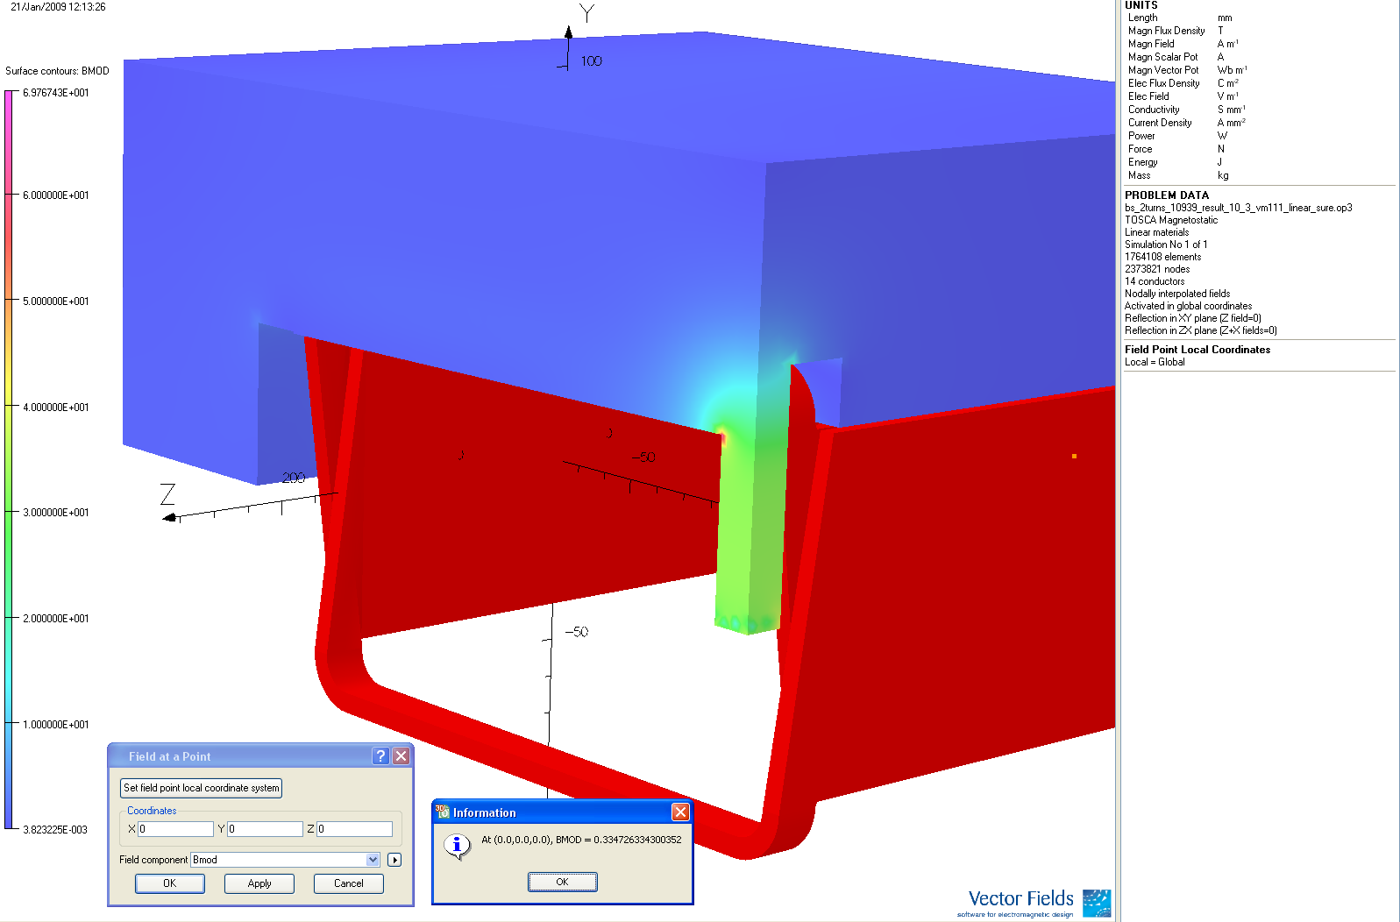

**BMOD @ Midplan in Z direction**

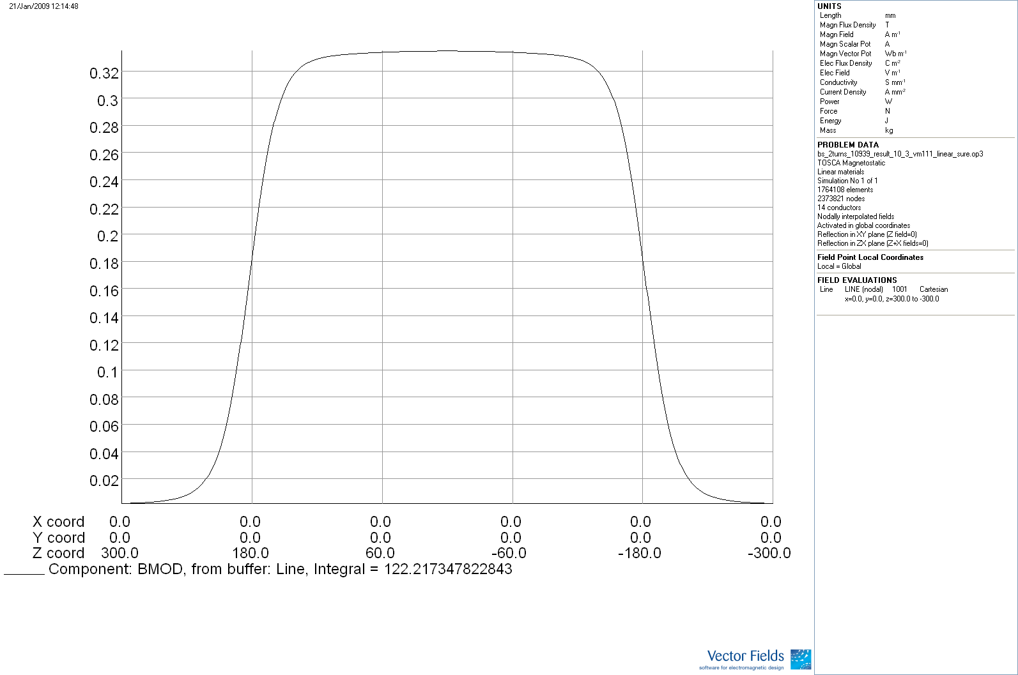

**Lequ : $\frac{122.2173}{0.33473}=365.122 mm$**

