Field distortion during ramp down of BS4

due to eddy currents in H⁻/H⁰ dump inside magnet aperture

B. Balhan, J. Borburgh

Assumptions
Magnet Gap 87 mm, Gap inside ceramic tube 65 mm
34 Amps/ mm² coil section ( 10/86 mm)
B0 @ Inom = 0.4217 T
Switch off ramp of 5 ms
Single Graphite dump block; conductivity 1.0E+05 Siemens/m,
Located at 23.5mm from 0 (magnet center)
Yoke material used in sumlations: VM111

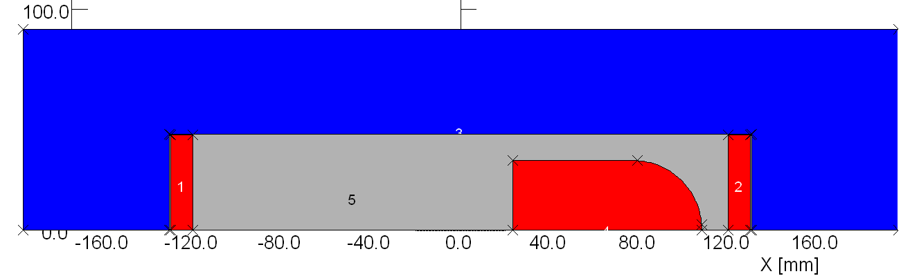
Geometry used in Vector Fields Opera 2D
Dump inside ceramic vacuum chamber. Simplified magnet geometry.

Time steps simulated
Assumed 5 ms ramp down , starting at 100 µs.

4 time steps simulated (red dots in graph)
- Beginning of ramps
- Halfway through the ramp
- End of ramp
- 1 ms after ramps stop

Fourier analysis of field from -20 < x < 20 mm (adjacent to the dump) at magnet mid plane.
It can be seen that the simulation during the ramp, mainly the DC field component changes: the higher harmonics are stable during the ramp (red and green curve, no eddy currents induced at beginning of ramp, i.e. blue curve). After the ramp (not shown) these values drop to the 10⁻¹⁰ T range.
The 2nd – 4th field harmonics, induced by the eddy currents in the dump, are in the 10⁻⁴ – 10⁻⁵ T range.
Not taken into account:
Field imperfections due to realistic cross section (cooling channels, multi turn coil)
Field imperfections due to end field effects

Conclusion
Amplitude of Fourier components of field on a line adjacent to dump (-20 < x < 20 mm) is during the ramp in the 10⁻⁴ – 10⁻⁵ T range.
Field uniformity of short magnet generally in 10⁻² – 10⁻³ range.
Compared with these, the influence of field distortion by eddy currents in dump seems negligible.

Case 1 @ t0 Iref 100%
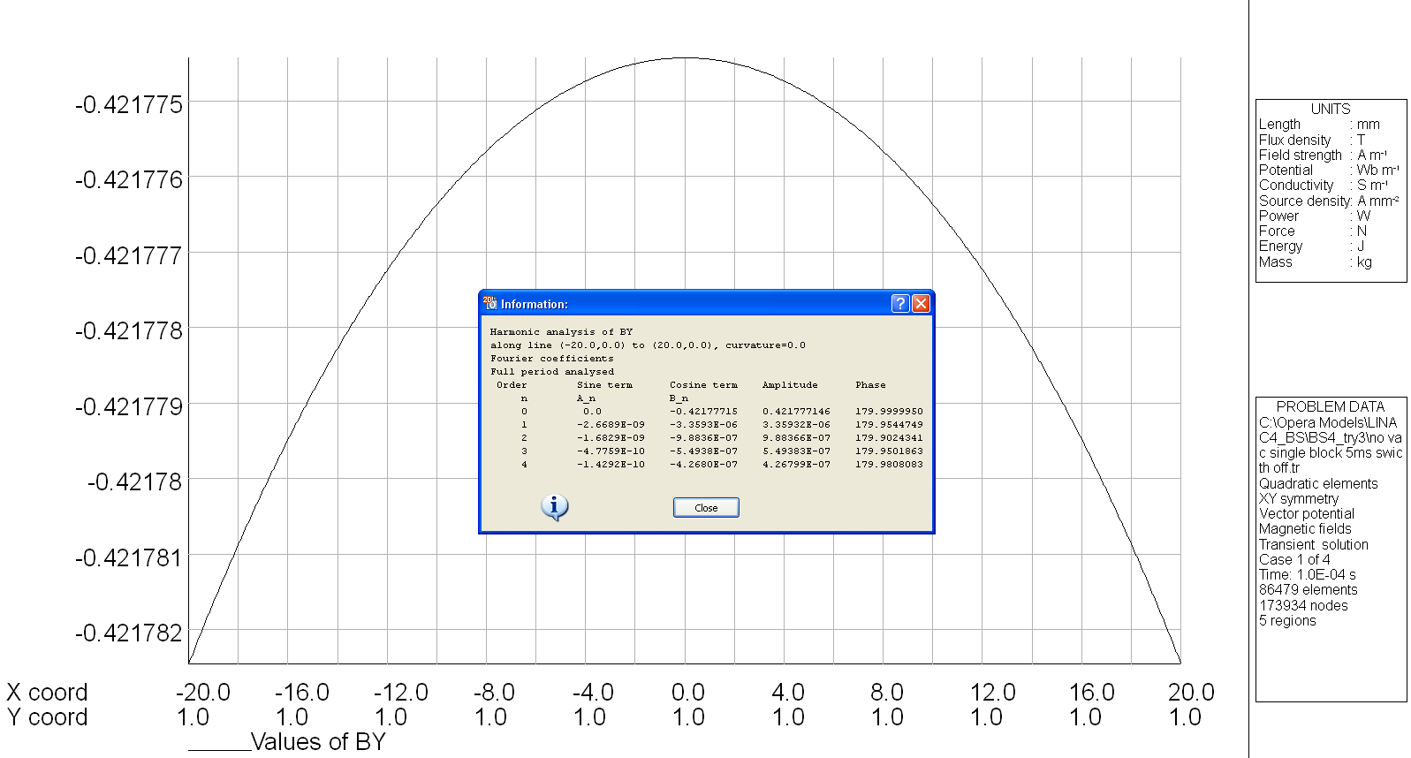

Dipole field 0.42 T ; higher order field components only due to imperfections in calculations
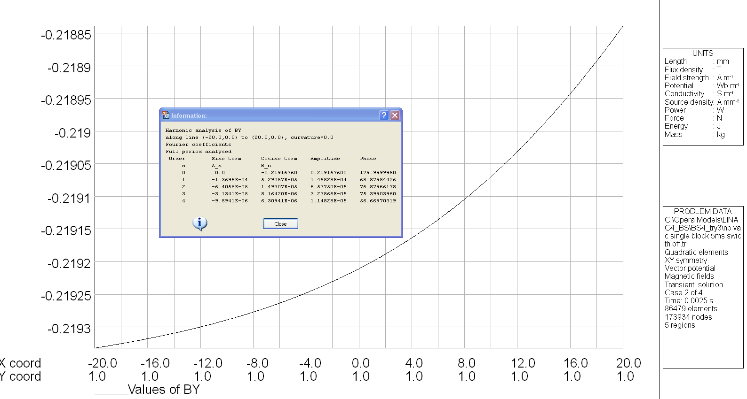
Case 2 @ t=2.51E-03 Iref 50%

Higher order field components provoked by eddy’s in dump: 10⁻⁴ Tesla, i.e. 100 higher values for these components than in previous time step.
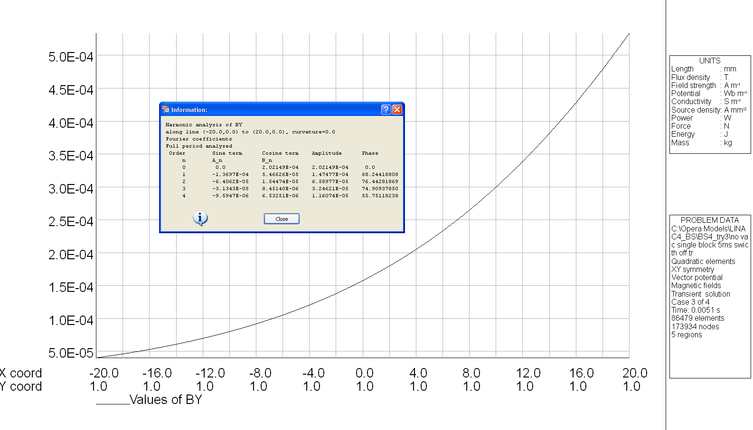
Case 3 @ t=5.1E-03 Iref 0%

Higher order field components due to dump: 10⁻⁴ Tesla
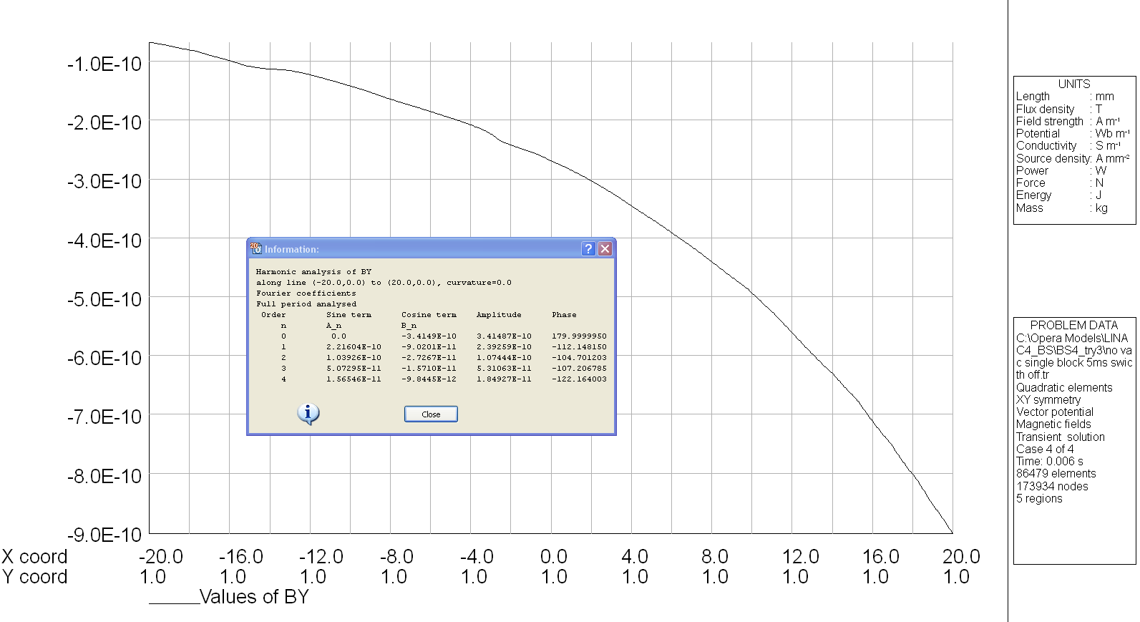
Case 4@ t=6.0E-03 Iref 0%
After ramp is switched off, higher order field components drop factor of 10⁵

