BS4 residual field depending dump conductivity

B. Balhan

Assumptions
Magnet Gap 87 mm, Gap inside ceramic tube 65 mm
34 A/mm² coil section ( 10/86 mm)
B0 @ Inom = 0.4217 T
Switch off ramp of 5 ms
Located at 23.5mm from 0 (magnet center)
Yoke material used in simulations: VM111
Single Graphite dump block; conductivity 1.0E+04, 1.0E+05, 1.0E+06 Siemens/m,

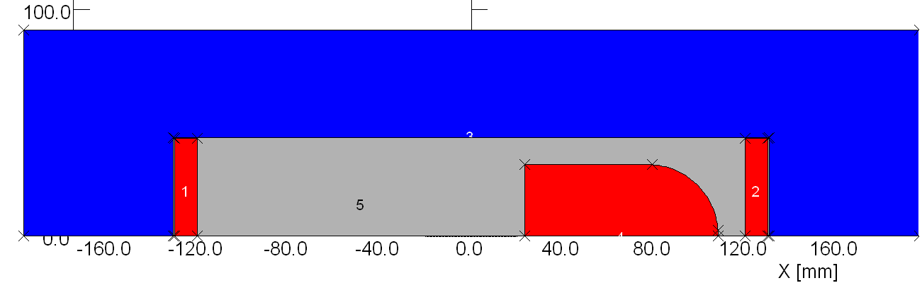
Geometry used in Vector Fields Opera 2D
Dump inside ceramic vacuum chamber. Simplified magnet geometry.

Time steps simulated
Assumed 5 ms ramp down, starting at 100 µs.

4 time steps simulated
(red dots in graph)
- Beginning of ramps
- Halfway through the ramp
- End of ramp
- 1 ms after ramps stop

